Financial Loan Analysis Project
1. Project Overview
This project analyzes financial loan data to evaluate lending performance and borrower behavior. The objective is to uncover insights into loan quality, repayment trends, and risk patterns to support better decision-making in credit management and risk assessment.
2. Dataset Summary
- Rows: 38,000+
- Columns: 2
- Key Features:
  - Loan details: id, loan_amount, term, interest_rate
  - Borrower information: emp_length, home_ownership, annual_income
  - Loan status: loan_status (Fully Paid, Current, Charged Off)
  - Financial metrics: total_payment, dti
- Missing Data: No
3. Exploratory Data Analysis using Python
We performed data preparation and cleaning using Python:
- Data Loading: Imported dataset using pandas
- Initial Exploration:
Used .info() and .describe() to understand dataset structure and statistical distribution
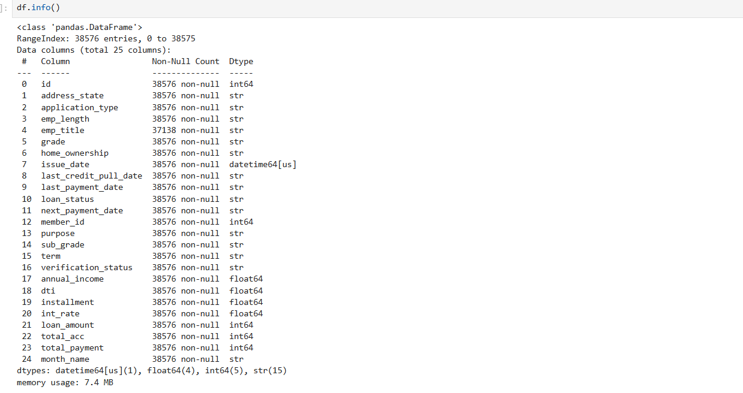
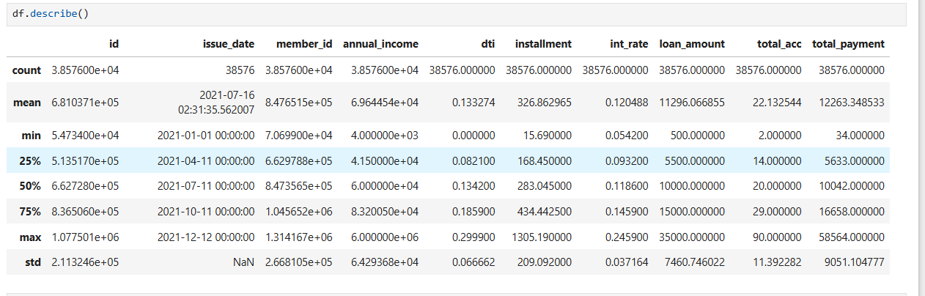
- Data Cleaning:
  - Checked missing values
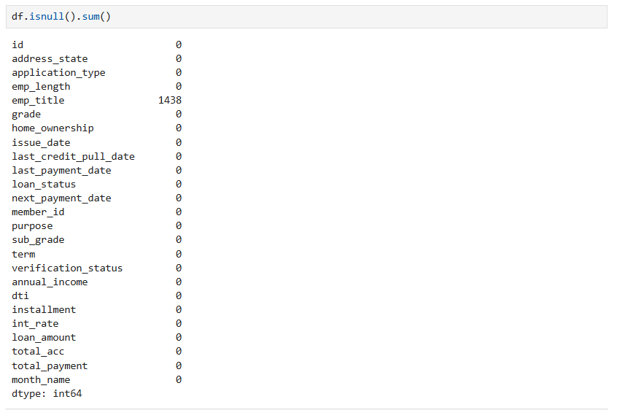
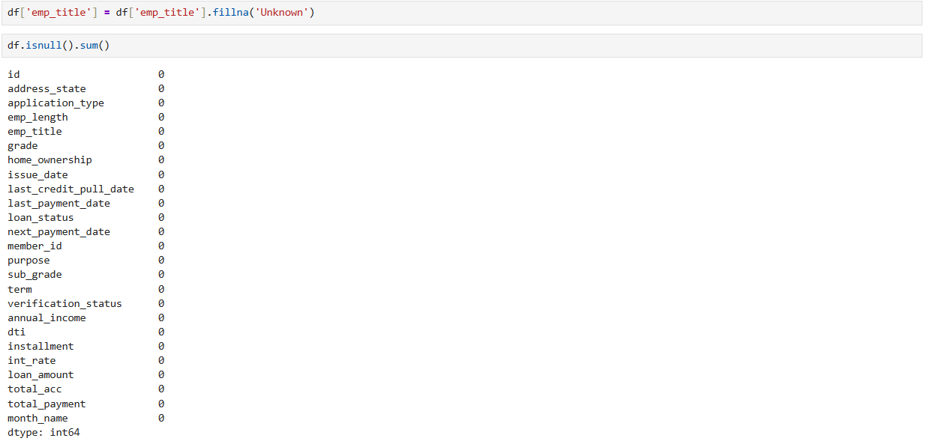
- Feature Engineering:
- Database Integration:
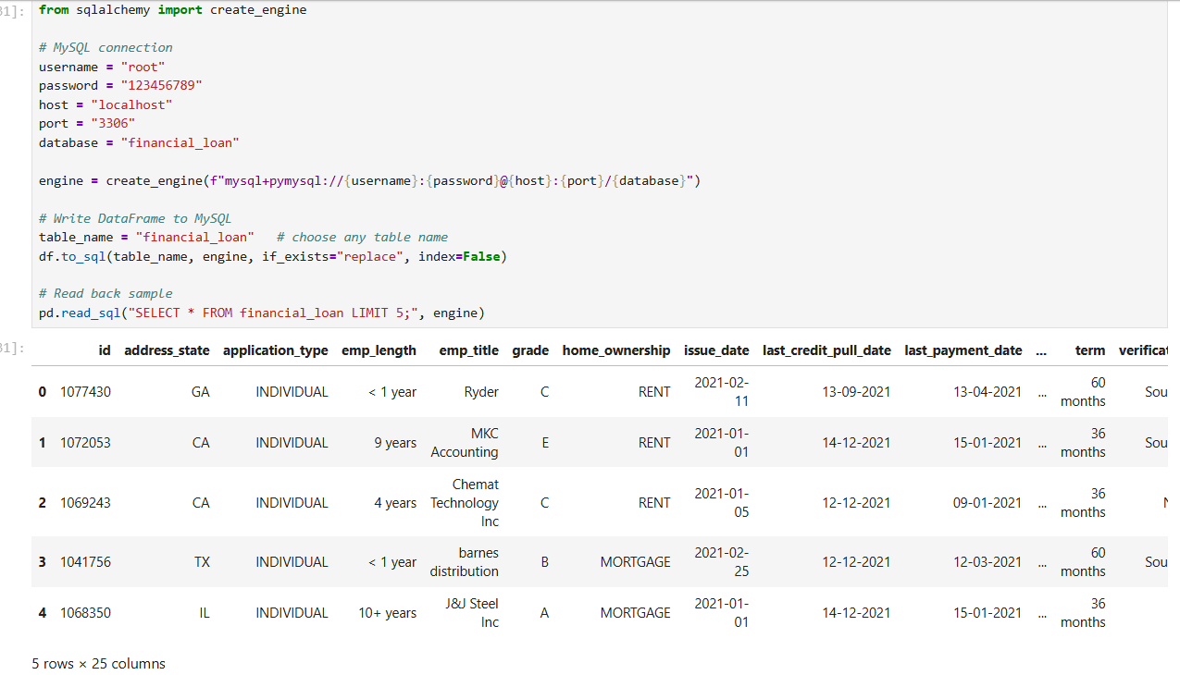
4. Data Analysis using SQL (Business Transactions)
Key Performance Metrics
- Total Loan Applications:
Total number of loan requests submitted
- Total Funded Amount:
Total capital disbursed to borrowers
- Total Amount Received:
Total repayments received from borrowers
- Average Interest Rate:
Average lending rate across all loans
- Average Debt-to-Income Ratio (DTI):
Measures borrower financial health
Loan Quality Analysis
- Good Loan Percentage:
Percentage of loans classified as Fully Paid or Current, representing healthy loans
- Bad Loan Percentage:
Percentage of loans classified as Charged Off, indicating default risk Loan Trends Analysis
- Monthly Trend for Loan Applications:
Analyzes the number of loan applications over time to identify trends and seasonality
- Term Analysis (36 vs 60 months):
Evaluates borrower preference between short-term and long-term loans
Revenue / Fund Distribution
- Funded Amount by Loan Status (%):
Shows how total funding is distributed across different loan statuses
- Funded Amount by Home Ownership:
Examines how borrower housing status impacts loan funding and repayment
Borrower Profile Analysis
- Loans by Employment Length:
Analyzes how borrower work experience relates to loan distribution
- Loans by Purpose:
Identifies the most common reasons for borrowing (e.g., debt consolidation, credit card, etc.)
Performance Analysis
- Top Segments by Funded Amount:
Highlights the segments generating the highest loan funding
- High Risk Segments:
Identifies segments with a high proportion of Charged Off loans to assess risk

5. Dashboard in Power BI
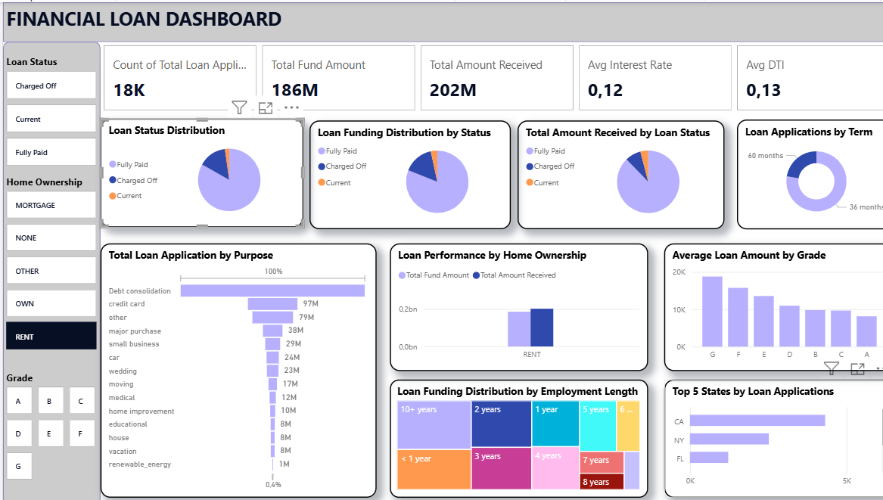

6. Business Recommendations
- Risk Control:
Focus on reducing Charged Off loans by tightening credit policies
- Customer Segmentation:
Prioritize low-risk borrower groups (stable income, long employment)
- Loan Strategy:
Optimize loan terms (36 vs 60 months) based on repayment performance
- Interest Rate Optimization:
Adjust rates based on borrower risk level
- Data-Driven Lending:
Use historical trends to improve approval decisions and forecasting.

